ENTOMOLOGICAL REPORT

ON

YELLOW FEVER OUTBREAK

IN

ENUGU STATE

INVOLVEMENT OF NATIONAL ARBOVIRUS AND VECTORS RESEARCH CENTRE (NAVRC)

JANUARY 2021

1.0 Background information
Following the confirmed cases of Yellow fever outbreak in Enugu state in November, 2020; National Arbovirus and Vectors Research Centre rose to support the Enugu State Government in an effort to reduce the epidemic impacts of the outbreak within the affected communities. This was also part of the measure to forestall the spread of the virus to contiguous communities, thereby upholding the health of all and sundry, within the areas. The Centre deployed teams of Entomologists to the affected LGAs to conduct immediate entomological assessment and to carry out environmental spray to bring down the population of the vectors.
2.0 ACTIVITIES

2.1 Advocacy and sensitization
Visit was paid to stake holders in the communities and house to house sensitization on the epidemiological aspect of the vector control were also carried out.

2.2 Larval indices determination, breeding habitat destruction and susceptibility test
The Aedes species composition, environmental assessment, risk factors such as mosquito density and larval indices, preferred breeding habitats of the mosquitoes were identified and destroyed. Susceptibility of the vectors to insecticides was done to determine the insecticide to be deployed for effective control. Viral assay of both mosquito and human samples were carried out in Igbo-Eze north LGA only, the information obtained was used as guide for other locations.
2.3 Environmental spraying
Based on the susceptibility test earlier conducted, pyrethrum (Deltamethrin) was selected as chemical of choice. Two mechanical sprayers were used. The concentration used was according to manufacturer’s instruction.
2.3.1 Igbo-Eze North LGA
National Arbovirus and Vectors Research Centre (NAVRC), conducted active entomological and virological activities at Ette and Umopu communities in Igbo-Eze North LGA of Enugu state where the outbreak was firstly reported. The Centre deployed team of entomologists and molecular biologists to the sites to identify the principal vector/s, determine vector diversity and density in the areas; and also determine the risk factors which includes the larva indices, and the possible risks of the diseases spreading to neighbouring communities.
The findings established the presence of Ae. africanus, Ae. luteocephalus, Ae. aegypti, Ae. albopictus, Aedes simpsoni and also revealed evidence of the vectors in close proximity to humans based on the high larval indices.
Sequel to these findings, the Centre recommended Deltamethrin for fumigation and in conjunction with the Enugu State Ministry of Health, carried out environmental fumigation of the affected communities.
Three other local governments reportedly affected were Nsukka, Igbo-Etiti and Isi Uzo. The intervention exercises in this LGAs commenced on 03/12/2020 with the aims of covering all the affected communities in each LGA.The blood samples collected are been analyzed for other arboviruses to rule out/established possible co-infections.
2.3.2Nsukka LGA
The team has completed fumigation and Entomology assessments and larval source management at Obinagu and Iseagu in Ezebunagu autonomous community Ehandiagu ward which were among the worst hit communities in Nsukka LGA. Other affected communities in Nsukka LGA where the fumigation exercise were carried out include: Opi-Agu, Breme, Agbamere, Ehalumona, Opi Uno and Umabo.

2.3.3 Igbo Etiti LGA
The team completed fumigation and larval source destruction at the three communities (Agu-Ekwegbe, Ekwegbe, and Umunko/Diogbe) also affected.
2.3.4 Isi Uzo LGAI
In Isi-Uzo LGA, five communities, (Onodu, Umuezeogbu, Umuezuboke, Umueje, Amudam) were visited, only environmental spray was conducted in these locations.

3.0 RECOMMENDATIONS
Based on the findings, the Team RECOMMENDS the following:
- There should be massive sensitization and social mobilization of the people on Yellow fever and its mode of transmission with emphasis on vector control considering the fact that vectors of yellow fever are also responsible for other diseases with debilitating effects. This is particularly important for the inhabitants of rural communities as majority of them do not know that Aedes mosquitoes transmit the Yellow fever virus.

- ACSM/Information, Education and communication (IEC) on prevention and control of mosquito-borne diseases should be intensified throughout the State, particularly:
- Tyres, metal and plastic drums should be properly covered when in use or after;
- Discarded materials especially sachet water and cans around human dwellings should not be allowed to hold water;
- Residents of the directly affected LGAs and the contiguous areas should commence immediate clean-up campaigns coordinated by the State Ministry of Health (SMoH). The fact that there is an outbreak and Aedes vector density is high, makes these locations very high priority areas for immediate intervention;
- Monthly entomological surveillance should be conducted by local authorities in the directly affected areas to monitor trends in vector density;
- The State should ensure commencement of community vigilance, search for more areas with high House Index ≥5% and/or Breteau Index ≥5.

Annex i
Table 1. Schedule for entomological intervention in Enugu state
S/No | LGA | Settlement/village | Activities | Date
1 | Nsukka | Obinagu | Mechanical and chemical (Funmigation) intervention | 3-4/12/2020
1 | Nsukka | OpiAgu | Mechanical and chemical (Funmigation) intervention | 6-7/12/2020
1 | Nsukka | Breme | Mechanical and chemical (Funmigation) intervention | 8-9/12/2020
1 | Nsukka | Agbamere | Mechanical and chemical (Funmigation) intervention | 10-11/12/2020
1 | Nsukka | Iseagu | Mechanical and chemical (Funmigation) intervention | 12-13/12/2020
2 | Igbo Etiti | Agu-Ekwegbe | Mechanical and chemical (Funmigation) intervention | 14-15/12/2020
2 | Igbo Etiti | Ekwegbe | Mechanical and chemical (Funmigation) intervention | 16-17/12/2020
3 | Isi Uzo | Onodu | chemical (Funmigation) intervention | 18-19/12/2020
3 | Isi Uzo | Umuezeogbu | chemical (Funmigation) intervention | 20/12/2020
3 | Isi Uzo | Umuezuboke | chemical (Funmigation) intervention | 21/12/2020
3 | Isi Uzo | Umueje | chemical (Funmigation) intervention | 22/12/2020
3 | Isi Uzo | Amudam | chemical (Funmigation) intervention | 23/12/2020
Annex ii
Photographs
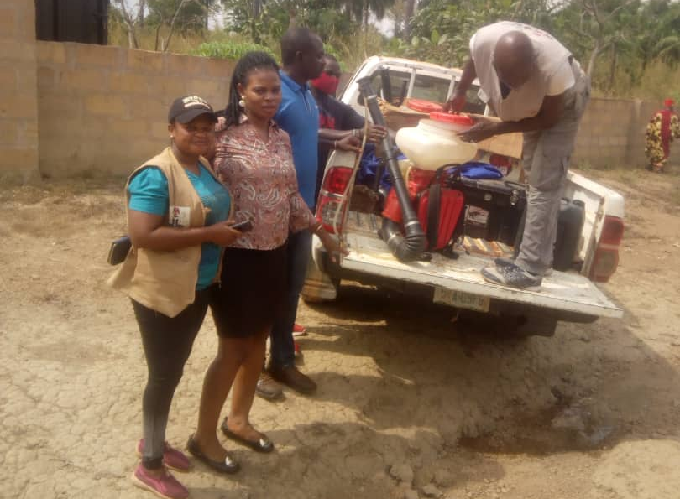
NAVRC team and the State Entomologist, second from left, getting ready for fumigation at Opi-Agu
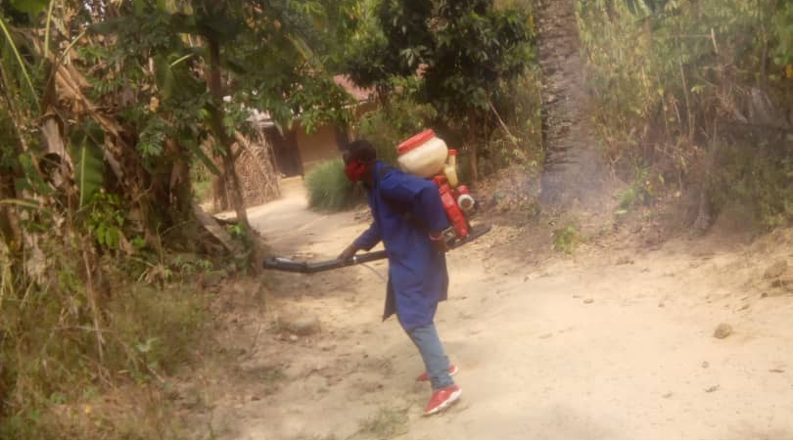
Fumigation being carried out at Igbo Etiti

